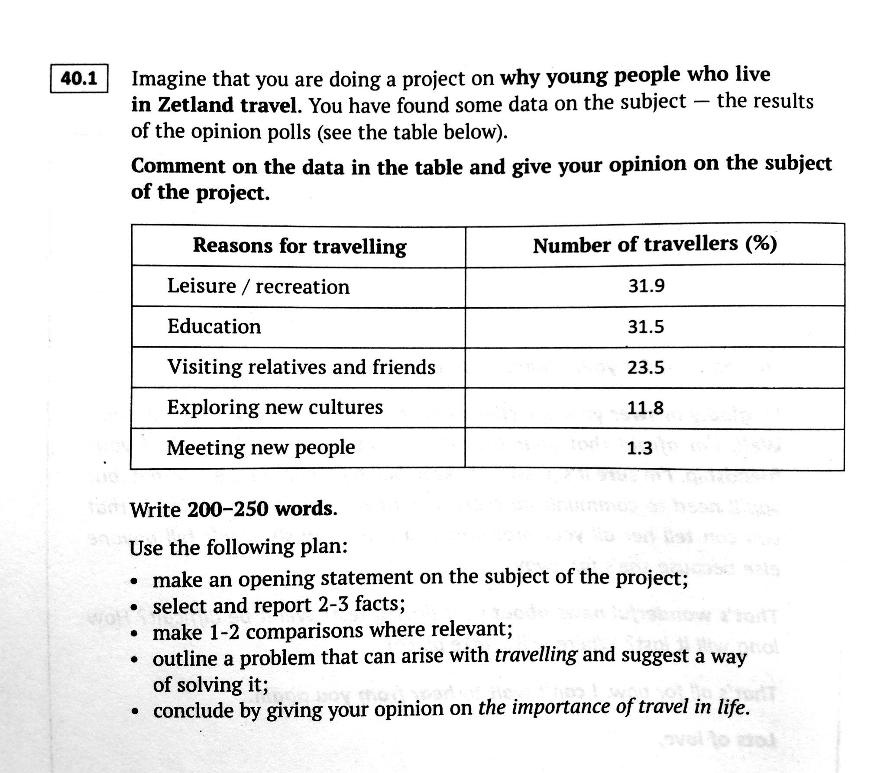

It goes without saying that travelling offers a lot of opportunities for young people, but there are various reasons why adolescents travel. I have been working on this project with the purpose of finding out reasons why youngsters from Zetland travel. I have found some useful statistics in the form of a table, to help give my opinion on the subject.

The table illustrates significant variation in reasons for travelling among adolescents. As can be seen from the table, leisure (recreation) and education are the most common reasons. The figures are 31.9% and 31.5% respectively. Visiting relatives and friends ranks below with 23.5% of the respondents. Roughly a tenth of those surveyed travel to explore new cultures or meet new people.

It is worth noticing that leisure is a great deal more popular than meeting new people, having a 31.9% popularity rating, in stark contrast with merely 1.3% for the latter. Exploring new cultures was named by 3 times fewer people than the top choices. It can be inferred that social contact appeals less to teenagers from Zetland.

The statistics point to an underlying problem: teenagers, and people in general, sometimes fail to explore new cultures and meet new people just because they do not speak English fluently and confidently. This gets in the way of open and sincere communication. So the solution to it is to apply oneself to English and practise it more.

In conclusion, despite the fact that travelling is usually rather expensive, it helps broaden our horizons and enriches our inner world.

Количество слов: 258

